HOME AUTOMATION PHASE II

# **PROBLEM STATEMENT:**

Switching on and off of the motor in our house is a bit complex.

Monitor the power used by house over a period of 30 days and display it dynamically

Monitor the power used the devices in a room in which our home automation kit is installed

# **AIM/OBJECTIVE**

Task – 1: To indicate the level of water in a tank using basic electronic components.

Task - 2: To monitor the Electric board readings regularly through an application

## **TASK 1 - USING TRANSISTOR**

# **COMPONENTS USED:**

* BC548C
* LED
* Motor
* Resistor
* Battery

## 

# **WORKING**

When the water level is low the 1st led turns on and when the water level increases gradually the other LEDs get turned on. Depending on the glow of LED we can get to know the level of the tank.

# **CIRCUIT DIAGRAM**

# 

# **MODEL/SIMULATION**

Click on the image below/the link to view the simulation

<https://youtu.be/-op-PYv-dEQ>

[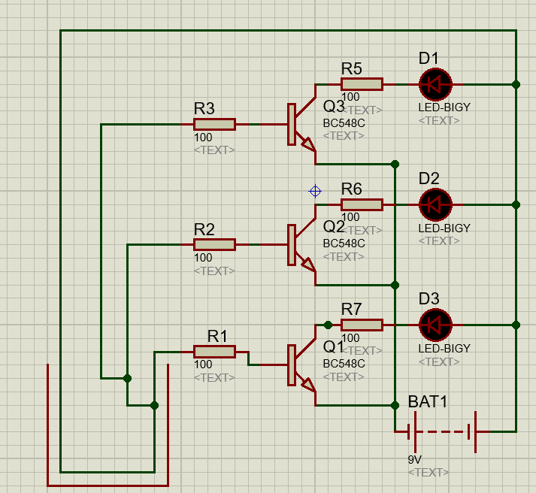](https://youtu.be/-op-PYv-dEQ)

**TASK 2:**

* Current sensor SCT-013
* Zmpt101b ac single phase voltage sensor
* Node MCU
* Capacitor
* Resistor

**WORKING:**

This project consists of Current and voltage sensor along with nodeMCU and blynk app. The sensor had to be clipped around the phase or neutral wire of the main connection and it works on the transformer principle. The voltage sensor measures the voltage and these two readings are used to calculate the power and kwt readings. This device updates the collected data to the blynk server and the data can be viewed using the blynk app in an android phone. NodeMCU consists of an inbuilt Wi-Fi module which eases the process of up linking the data to cloud.

**BLOCK DIAGRAM:**

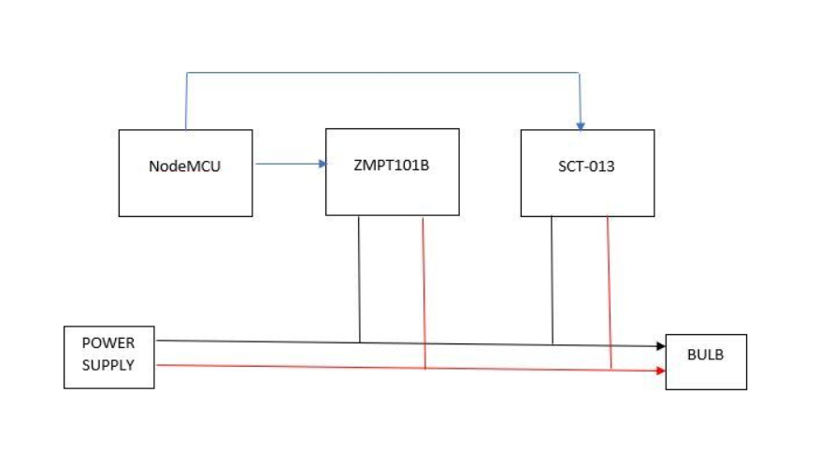

# 

# **COMPONENTS EXPLANATION**

## **SCT-013 Current Sensor**

i) WORKING PRINCIPLE: A current carrying conductor generates uniform magnetic field around it. A current transformer has a primary winding, a magnetic core, and a secondary winding.

ii) SPECIFICATIONS

Input Current (RMS): 0∼100A

Turn ratio: 100A:0.05A

Output Current: 0-50Ma

## **ZMPT101B AC Single Phase Voltage Sensor**

i) SPECIFICATIONS

1.Voltage up to 250 volts can be measured

2. Lightweight with on-board micro-precision voltage transformer

3. High precision on-board op-amp circuit

4. Operating temperature: 40ºC ~ + 70ºC

5. Supply voltage 5 volts to 30 volts

ii) DESCRIPTION

The ZMPT101B AC Single Phase voltage sensor module is based on a high precision ZMPT101B voltage Transformer used to measure the accurate AC voltage with a voltage transformer.

## **Blynk App**

The readings of the sensors in terms of current, voltage and power can be viewed through the blynk application.

## **Libraries required**

i) EmonLib Library

ii) Blynk Library